Survey Results, Proposal and Discussion on a
Mixed Use Walking/Bicycle Path on Chappaquiddick
Chappaquiddick Path Committee
August 31, 2008
Executive Summary
- Over the past two years, the Chappaquiddick Path Committee (CPC) was formed to promote the development of a walking/bike path system on Chappaquiddick
- At the public meeting with the seasonal residents, the Edgartown selectmen indicated that they were in favor of pursuing a bike path on Chappy if the residents were in favor of it.
- The CPC conducted a survey of Chappy Residents with the help of the CIA – Over 70% of the more than 200 respondents indicated that they favor the concept of a bicycling/walking path.
- The CPC is now developing a possible layout of the path in Phases for review and discussion with the Chappaquiddick community and town officials
- The CPC believes that this should be an open, democratic process so that the best alternative approach is selected and implemented.
Results of Survey. In August 2008, the Chappaquiddick Path Committee (CPC) undertook a survey of Chappy residents by email to determine the extent of support for a mixed use walking and bicycling path. The survey was distributed to Chappaquiddians with email addresses known to the CPC or to the Chappaquiddick Island Association (via the President of the CIA). Overall, >500 emails were sent out. As of August 27, 2008, when the survey results were tabulated, we had received 233 responses, excluding blanks (3) and duplicates (25).
The questions were:
- In principle, I favor the implementation of a mixed use bicycling/walking path on Chappaquiddick. --Yes/No
- I would like to join the group working on this project. –Yes/No
- I would like to receive periodic emails with updates of the progress, including the results of this survey.—Yes/No
The results were overwhelmingly in favor of the path (Question 1):
34 people volunteered to join the group working on the project (Yes to Question 2), and almost everyone wanted to receive updates of the progress (96% Yes to Question 3).
Proposal . Based on the broad, supermajority support for a mixed use path revealed by the survey of Chappy residents, the CPC will begin working towards implementation. The Steering Committee recommends that year round recreational paths be constructed on Chappaquiddick in three phases. We believe that a phased implementation will increase the chances of achieving our goal. Review of past surveys and our observations suggest that some routes are potentially easier to construct and some routes are more needed due to traffic. Phase I, the top priority based on benefit and feasibility, is a path from the ferry to Dike Bridge. Phases II and III would follow, based on the success of the first path, and could extend the path towards Wasque or other possible routes on Chappy, respectively.
The design of the recreational path should be esthetically appealing, in keeping with the rural character of Chappaquiddick, and made as safe as possible. As much as feasible, it should be separated from the road. Most of the path can be done along pre-existing rights of way owned by the Town in some areas with slight shifting of the pavement within the right of way. Easements may be needed for certain areas (with fair compensation). We plan to promote discussion of these efforts, develop a specific plan and take these forward for approval, funding and implementation.
Rationale. On Chappaquiddick ever increasing numbers of cars, trucks, bicycles, walkers and joggers share a narrow two lane paved road and many sand roads. Cars and trucks have to move into the oncoming lane to pass the pedestrians and bicyclists. When two cars/trucks approach from opposite directions, one has to slow or stop, or the bicyclist or walker has to go off the road. For many, young and old, bicycling or walking in the road is unfortunately not an option because of the safety hazard. Numerous sand roads running from paved roads to get to public beaches and to many houses. Sand roads that are intermittently soft are difficult for bikes, especially children. Cars overload the parking lots at the ferry and at the beaches, in part because biking or walking is not considered safe by many Chappy residents.
No one can argue about the importance of the natural beauty of Chappy and the need to preserve it. We seek to minimize the interference of traffic with this experience. At present playing dodgem with passing cars and trucks is stressful to walkers, bikers, and joggers, not to mention the motorists. Many would ride bikes if they perceived it as safer. It will be especially appealing for parents with children who otherwise probably would not be able to ride their bikes on Chappy.
Bicycling, walking and jogging afford multiple health benefits in addition to the opportunity to enjoy our beautiful island. A separated path provides an efficient, enjoyable and safe means of transportation- a way to the beach and to town without depending on cars. The path will further our efforts to make Chappy greener by reducing gas consumption and will decrease the demands on the parking lot and ferry.
The greatest benefit will be to the Chappaquiddick residents who bicycle or walk or who would be able to do so with a path. Many Chappaquiddians bicycle already. In the summer, the number of bikes in the rack at the ferry is about 50% that of cars in the parking lot. At times, the count was over 40 bikes. While it is likely that more bicyclists will come to Chappy (they already do come in great numbers), some will substitute a bike for a car, reducing car traffic and ferry lines. Furthermore, the path will keep the bicyclists out of the way and able to get to their destination efficiently.
Next steps. The original Chappaquiddick Path Committee (CPC) has been expanded to include the volunteers identified through the survey and is now comprised of over 30 Chappy residents. The CPC will be guided by a steering committee, who prepared this document. The CPC will promote discussion of specific designs, funding and implementation of this proposal. We believe that through a democratic process that listens and responds rationally to the arguments for and against, a suitable design can be developed that will have widespread support. The CPC will be communicating by email and meeting in person intermittently as time permits to refine their strategy.
The CPC will bring forward the results of the survey and proposal to the Edgartown Selectman, the Land Bank and the MVC and ask their advice and support. We anticipate working with Chappy residents, community leaders, the MVC, Trustees of Reservations and other planning groups at the local and state level to develop a satisfactory design and funding for the Chappy Path. We will encourage open discussion at the CIA and other venues. Updates on the progress of these efforts will be provided to anyone who wishes to be included in the email list.
Chappy Residents debate the Pros and Cons.
As expected many statements pro and con were included in the survey email responses or communicated to the CPC verbally. We have tabulated some of these comments below, along with a response by the CPC for further consideration by the Chappy community. We believe that a rational approach to the issues will ultimately weigh strongly in favor of the path.
We have organized the comments into seven categories:
More people | Sand
Safety | Design
Speeding | History
Rural character

However, these recent pictures on Chappy make the case most eloquently.
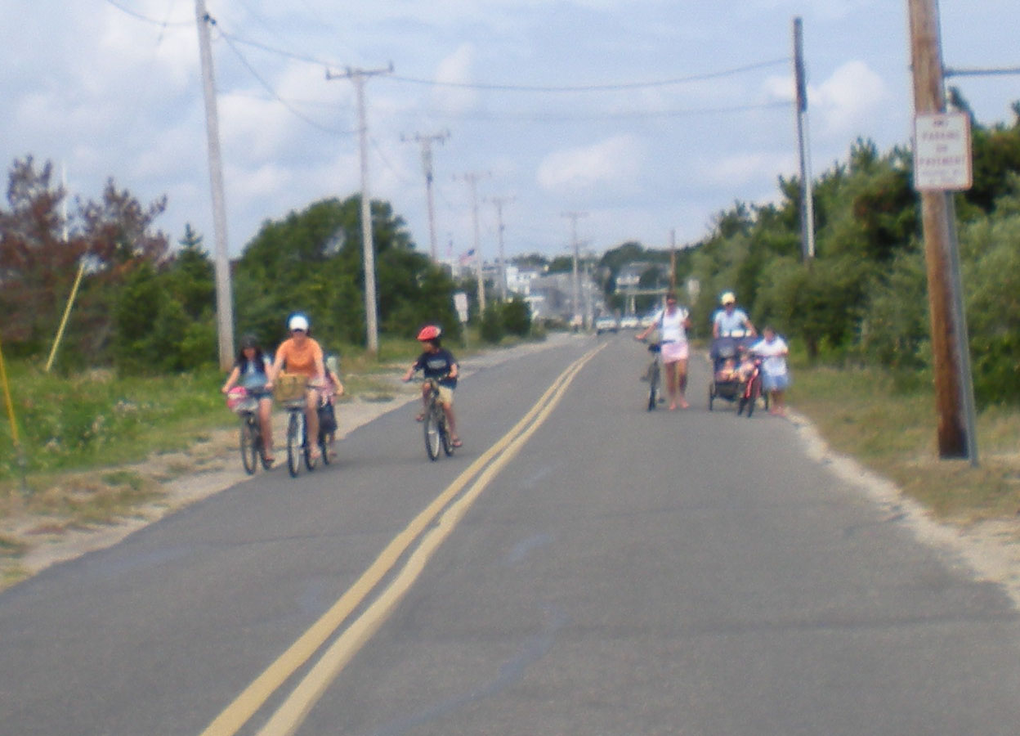

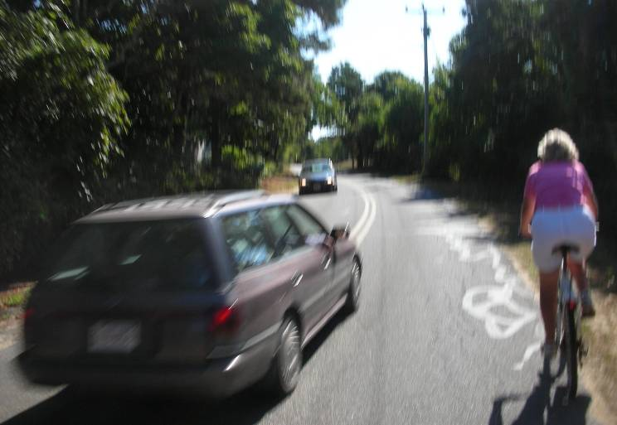

Comments: More people | Responses
On nice days, a significant percentage of the hundreds of MV visitors who rent bikes would come to Chappy. Large numbers will increase the likelihood of accidents. When multiple bikes are loaded and organized on the Chappy Ferries, trips seem to take longer than usual. If correct, this will increase the time spent in Ferry lines. | We would all agree that more time spent in Ferry lines is bad (unless you use it as a way of keeping people away from Chappy). However, the main reason the ferry line is long is because of cars, not bikes.  Will the bike path significantly increase the number of bikers coming to Chappy? Perhaps it will, or perhaps more bikers mean fewer tourist cars driving onto Chappy which might actually decrease the ferry lines.  Large bike parties may increase ferry lines: It’s hard to believe that loading bikes slows the ferry significantly, but if you allow that argument to affect whether a bike path is built you are using the scare tactic of confusing unrelated issues. Extrapolating from a bike path to more bikers and from more bikers to slower ferry lines requires not one but two unsupported assumptions and is less an argument than speculation.  One could argue that to the extent bikes replace cars coming over to Chappy the net effect could be beneficial.
Many of us believe that the more troublesome (and expensive) it is to get here, the more folks will stay away. | To paraphrase, “Let’s make Chappy unpleasant so everyone will stay away.”  Most affected by “troublesome” and “expensive” are the Chappy residents. Better to make the visitors less visible and able to go to their destination (usually the beaches) with minimal effect on the residents.  It is clear that the greatest benefit by far of the proposed path will accrue to the year round and summer Chappy residents, who ride, walk or bike the island roads almost every day we are here, even if we have to share it with a few more visitors.

Comments : Safety | Responses
Can you tell me what the rationale is behind the present proposal? If it is safety, has anyone come up with anything to back it up? I'd love to know about it. It would be hard to argue against a bike path if it actually made things safer. | Important point, since safety is a central argument. The vast majority of fatal bicycle accidents involve a collision with a vehicle (92% in one study of 225 fatalities), a risk that will be greatly reduced by a separate bicycle path. Bike paths do not prevent other accidents between bikes or between bikes and pedestrians. This can be minimized by the design of the path, including an ample width, separation of the lanes, signage and good visibility.
I have not known of a single auto-bike collision on Chappy. | According to the computerized records of the Edgartown police, from 1988-2005, there were 8 serious bicycle accidents on Chappy that were reported to police. None of these involved a collision with a vehicle, although a role of vehicles in the accidents, such forcing off the road, is not excluded. During this time there were 35 motor vehicle accidents on Chappy, 6 involving injuries. Any role of bicycles or pedestrians in these accidents is similarly unknown.  The past is no indication of the future. We have observed many a near-miss over the years and the congestion on the roads is increasing.
Over its length, a bike path will intersect with at least 50 dirt driveways. At many of these intersections, visibility for bikers and for drivers coming out of driveways will not be good. Drivers who do not slow down or stop and look both ways could easily strike a child or adult passing over their driveway. Many drivers will be guests or renters not aware of this danger. But even owners, like myself, could be forgetful or careless. Also, it would not be wise to count on the cyclists stopping to look three ways at each of the 50 intersections. Obviously, none of us would like to cause a serious injury or death. | Whether bikes are on a path or on the road there will be intersections with driveways. Drivers exiting their driveways have no greater chance of being careless if there is a bike path. Fewer interactions with cars, not more will be the consequence of the path.  A recent survey of the proposed Phase I route from the ferry to the Dike Bridge reveals only 11 driveways and 6 roads. Each was surfaced with sand, which itself would prompt a bicyclist to pay attention. The driveways probably have little traffic (none seen during the survey).  While this survey was conducted on a bicycle, we were passed by 21 cars/trucks each of whom had to either cross over to the oncoming lane or slow down behind us, if oncoming traffic was present. On the highway we passed six children bicycling, many adult bikers and walkers and two strollers (one double wide).

Comments : Speeding | Responses
Many of us can get frustrated when we have to slow down or stop for cyclists. We could often go faster if bikes were not on our roads. Some drivers would end up going much faster. This would increase the chance of accidents. | Bikers as speed bumps - interesting point, but hopefully not serious.
The bikers and walkers help to keep drivers going slowly. | As above. Let’s do not rely on people to slow down the traffic.
Prior to building a new road we should enforce the laws on the books today. The 25 MPH speed limit is mostly ignored by Chappy residents, workers and visitors alike. Vigilant enforcement of speeding laws and increased signage are effective ways of changing habits. Enforcement is cheaper, can be implemented immediately and aesthetically more pleasing solution to the risk of injury or death to cyclist and walkers by automobile vs. building a walkway. | Agree we need to reduce the speeding on Chappy through the measures suggested.  However, even if everyone drives at 25 mph, the hazards to walkers and bicyclists forced off the road and the stress to motorists forced to stop or change lanes on curves will remain.  There has only been limited, if any, improvement in the speeding over the last 10 years, despite some effort by the Edgartown police.
Some cyclists would still use the road, even if there was a bike path. | Those biking closer to the speed limit (25 mph) may find it easier and safer. However, there are many not able to ride that fast or who should not get close to traffic (children).

Comments : Rural Character | Responses
We have an unspoiled rural island and we want to keep it that way. We are so fortunate to have this unspoiled landscape and I wish the people who come here because of its beauty wouldn’t keep trying to ruin it. The bikers and walkers love it and enjoy coming here and the way it is. | Hardly unspoiled, considering the increasing car and truck traffic. Not clear how a bicycle/walking path “ruins” the beauty. In fact it has potential to increase the beauty and enjoyment of the island for those who choose not to drive.
Bicycle paths will drastically change the character of Chappy. Let them use the roads if they really want to see the place. | The “character” of Chappy is hard to define. The character should include respect for those who wish to have alternatives to driving a car and safety for all. The “them” in this argument is mostly “us.” The main beneficiaries by far will be the Chappy residents.  Would it really “drastically” change the character to allow an alternative route for walkers, joggers and bicyclists out of our traffic?
More bikers will increase the trash on the island. | In fact, you rarely if ever, see trash on bicycle paths. One reason is that it is difficult to eat, drink or smoke on a bike, as opposed to a vehicle. Most of our trash along the roads comes from cars and trucks. The other reason is that bikers in general have great respect for the environment and that is one of the motivations to bicycle instead of drive.
We like our rural roads and don’t want them paved either | We do not propose paving roads but only the provision of a safe and esthetically pleasing path for those walkers and bikers who choose not to walk or bike in the road.

Comments :Sand | Responses
One consistent MV problem is clearing sand from bike paths - sand makes the path unsafe and dangerous. Unless we have a budget for labor and equipment to sweep the sand off - this could create a big safety problem. | Should be no more sand on the path than on the current road (or shoulder) which is the only current alternative.  A paved path even with a layer of sand would be an improvement over the roads that pure sand and often soft.  Bikers on Chappy are used to sand, since they have to go down sand roads to beaches.
As cars drive on dirt drives over the bike path, and with rain wash off, sand will be on the bike paths at many intersections. Sand will also be washed on to the bike path in places where it is down gradient from the road-particularly where the road is not paved out toward Wasque. Sand on bike paths is very dangerous! In fact, in the few places where sand has accumulated on the Chappy paved road, there have been some serious falls causing bad injuries. The problem would be increased many fold on a bike path. | The bike path will intersect driveways where the road now intersects driveways. The same sand from driveways that may mar the smooth surface of Chappy Road may mar the smooth surface of the bike path if it is along Chappy Road, but the presence of a bike path will not increase the chance of a biker encountering a little sand on his path. Secondly, the bike paths along other sandy areas of the island, such as State Beach, do not accumulate the dangerous amounts of sand you warn of, and in fact are quite smooth in my experience (I have biked and rollerbladed over the Beach Road path many times without encountering any "dangerous sand.) Lastly, only deep sand presents a significant problem for the fat tire mountain bikes that are the predominant bike these days. A little sand, unlike a little knowledge, is not a dangerous thing.

Comments: Design | Responses
In concept, I would like a walking, biking path. Need to know more of width & location of path before voting in favor. | Agree, but before we can get to the design stage, we needed a clear sense of whether Chappy residents supported the concept, which fortunately they do by a considerable margin. This support can be used to encourage the town to develop the best design possible and bring this back for further discussion and refinement by the Chappy community.
Don’t want to widen road enough for a bike path. Only in favor if path is separated and set back from the road like the bike path on the West Tisbury Rd. | Many advantages to this type of path. Main limitation is getting easements through the properties. May be possible for some of the path.
Safest would be to get two narrow one-way bike paths, one on each side of the roadway, marked for travel in the same direction as traffic flow. The relatively narrow one way paths diminishes bike-bike, bike-car, bike- pedestrian accidents and provide for much safer conditions for all involved. Plus, casual walkers are far less apt to use the road-shoulder bike paths to lollygag and dilly dally. | We believe this excellent suggestion should be seriously considered as an alternative for at least some of the path.
I favor a biking/walking path but only if it's the kind of path I'd like to see, which is more about what I don't want to see - paved, wide, and no bridge structure next to Caleb's, etc. One idea I had is a one-bike-wide path on both sides of the road - like a tow path for a horse next to a canal, and dirt or some permeable natural type surface so it looks like a path. | Paths on both sides of the road are worth considering. However, “dirt or some permeable natural type surface” is not good for bikers and would require more maintenance.
If we have to have bike paths I hope they would not end up looking like the bike paths on the Edgartown- Vineyard Haven Rd and the Katama Road, which have lost almost all the grass on the strip separating the path from the main road. This is a real eyesore. The remedy would be to have greater separation, enough to allow trees and natural vegetation to remain as a real buffer between the two. I would think many property owners along the road would prefer this even if it meant giving up a few feet of their property because the outcome overall would be so much better looking and could actually afford more protection from the road. | Agree with this analysis—a moderately separated path is the first choice wherever possible.

Comments: Design | Responses
Mixed use bi-directional paths are dangerous unless they are very wide, have smooth pavement, good drainage, and are free of debris - especially sand. Bi-directional mixed use paths generally, create a high likelihood that pedestrians, especially mature and elderly strollers will be injured by inexperienced bike riders. Also, pedestrians bring leashed dogs, kiddie-strollers, baby carriages, toddlers and youngsters with training wheels on to a mixed use path which often soon renders it unsuitable for bicycle riders and walkers alike. A mixed use path is generally ill advised. | We already have a mixed use bidirectional path, namely our roads, which cars and trucks share with “bicycle riders, walkers, pedestrians with leashed dogs, kiddie-strollers, baby carriages, toddlers and youngsters with training wheels.” At least these will not encounter a motor vehicle on the proposed mixed use path. Almost all serious injuries to bicyclists involve a motor vehicle.  In Boston the Paul Dudley White Bicycle Path along the Charles River is mixed use, approximately 6-8 feet wide and quite pleasant. With far more users of the type mentioned in the comment than we would ever have on Chappy, the people adapt and are able to share the space without significant problems.
We will not be able to get easements. | Edgartown owns 50’ right of way along the paved road and 30’ along sand roads (e.g. Dike Bridge and Wasque roads). Paved road is ~20-22’ wide, permitting an 8’ wide path without requiring easements along most of its course. Some easements will be required or the road shifted slightly, as the roads are not always centered on the rights of way.  Some utility poles may have to be removed and the wires buried, which would add to the expense but also to the esthetic benefit.  Edgartown would presumably pay a fair price for the easements to those willing to allow the path. However, it is not necessary for the path to be perfect and occasional narrowing or return to the roadway may be more acceptable to the Chappy residents that taking land by eminent domain.  Some have already volunteered easements on their land for the path (along Chappy Road and at Wasque).
Walking path- yes (not paved bike path) | More walking paths are also desirable but do not address the needs of bicyclists.

Comments: History | Responses
Why can't we settle it once and for all instead of having to fight it ever 4-5 years? | We would like to settle this once and for all, through a democratic, open and transparent process that listens and responds rationally to the arguments for and against, and does not give anyone, no matter how vocal or litigious, veto power over the majority.
This community was divided down the middle a few years ago about this idea. | We are no longer divided down the middle: according to a survey results from over 200 Chappy residents, including the CIA membership, the overwhelming majority favor a mixed use bicycle/walking path (70%). Times and opinions have changed—more interest in health, gas savings, and safety concerns about the ever increasing car/truck traffic.
On about six occasions since 1970, this matter has been vigorously advocated - usually by mostly new property owners, and after much discussion, dismissed by the majority. | Times change and so does the majority view. At the present time support is broad and cannot be dismissed as “mostly new property owners”. In any case, in a democracy the new are entitled to an equal voice in matters that concern their community and the public good.
Chappy Path Committee Members (as of August 31, 2008)

